***Murder Mystery SQL***

**STEP 1**

**SELECT \***

**FROM crime_scene_report;**

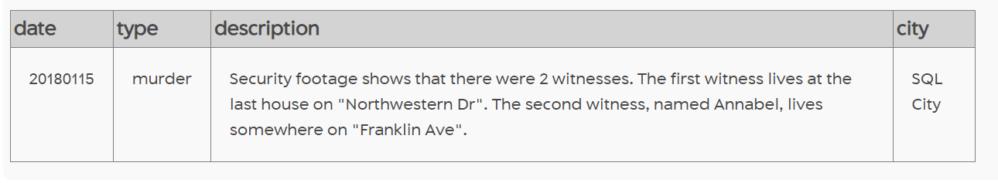

**STEP 2**

**SELECT * FROM person WHERE address_street_name = 'Northwestern Dr' ORDER BY address_number DESC LIMIT 1**

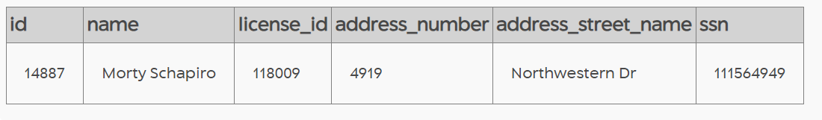

**STEP 3**

**SELECT * FROM person WHERE address_street_name = 'Franklin Ave' LIMIT 10**

**)**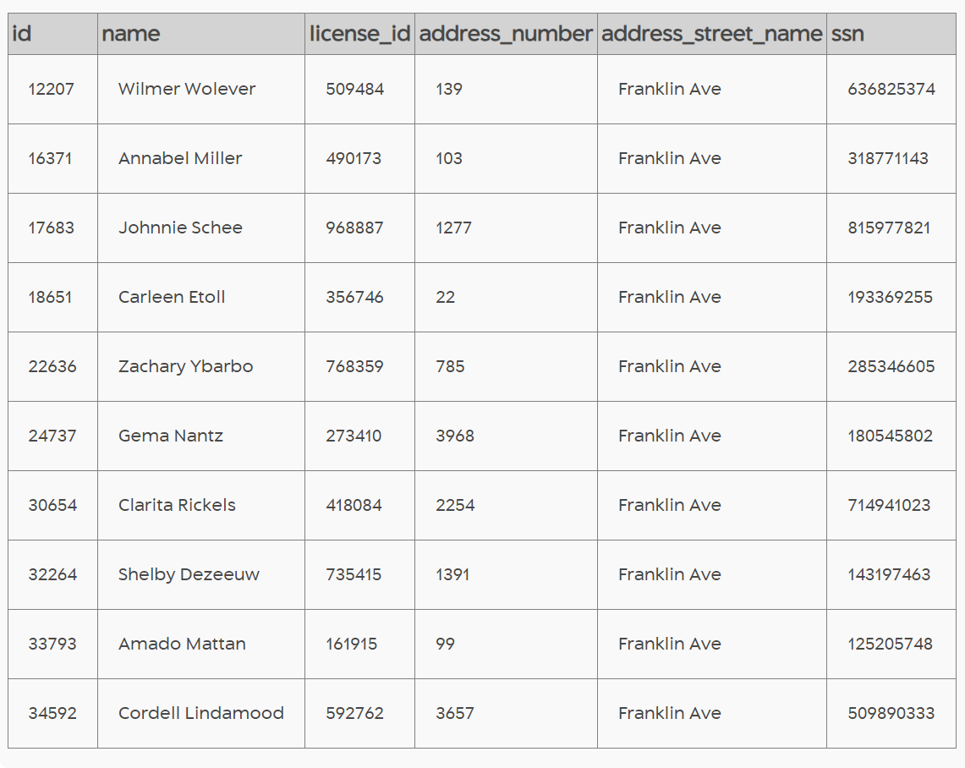

**STEP 4**

**SELECT * FROM person WHERE address_street_name = 'Franklin Ave' AND name LIKE '%Annabel%' LIMIT 10**

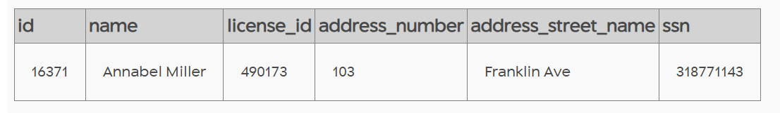

**STEP 5**

**SELECT * FROM interview WHERE person_id IN (14887,16371) LIMIT 10**

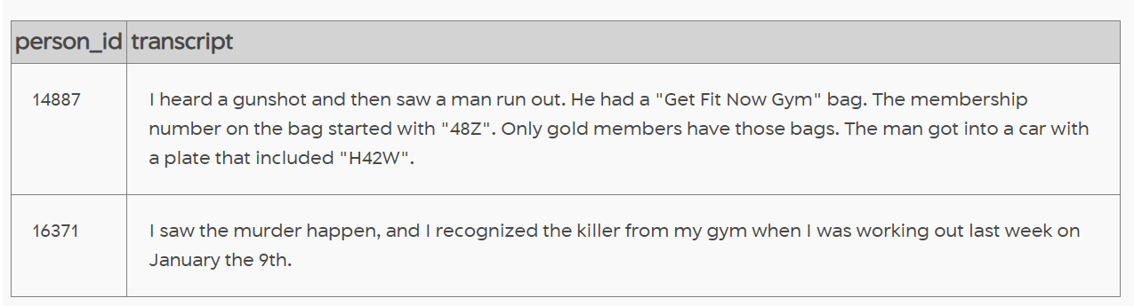

**STEP 6**

**SELECT * FROM drivers_license WHERE plate_number LIKE '%H42W%' LIMIT 10**

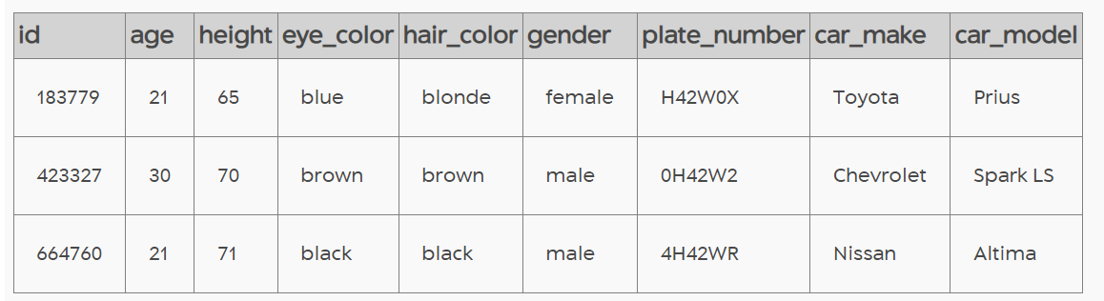

**STEP 7**

**SELECT p. * FROM drivers_license as d1 INNER JOIN person as p on d1.id = p.license_id WHERE plate_number LIKE '%H42W%' LIMIT 10**

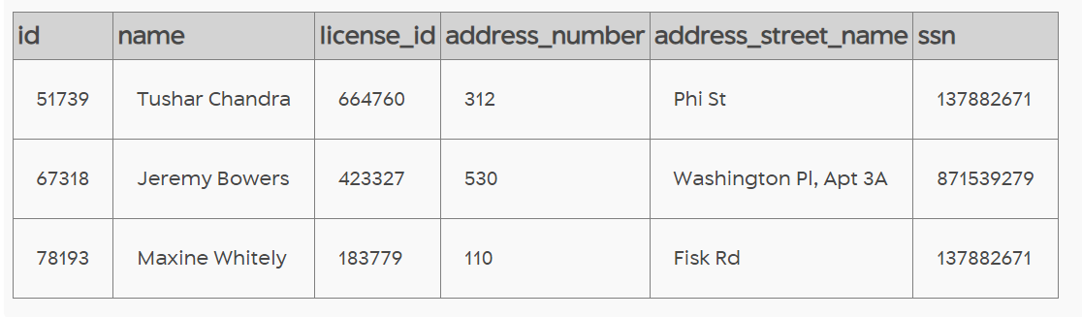

**STEP 8**

**SELECT p. * FROM drivers_license as d1 INNER JOIN person as p on d1.id = p.license_id INNER JOIN get_fit_now_member as gf on p.id = gf.person_id WHERE plate_number LIKE '%H42W%' LIMIT 10**

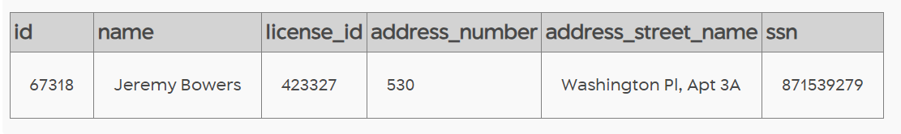

**STEP 9**

**SELECT p. * , gf.* FROM drivers_license as d1 INNER JOIN person as p on d1.id = p.license_id LEFT JOIN get_fit_now_member as gf on p.id = gf.person_id WHERE plate_number LIKE '%H42W%' LIMIT 10**

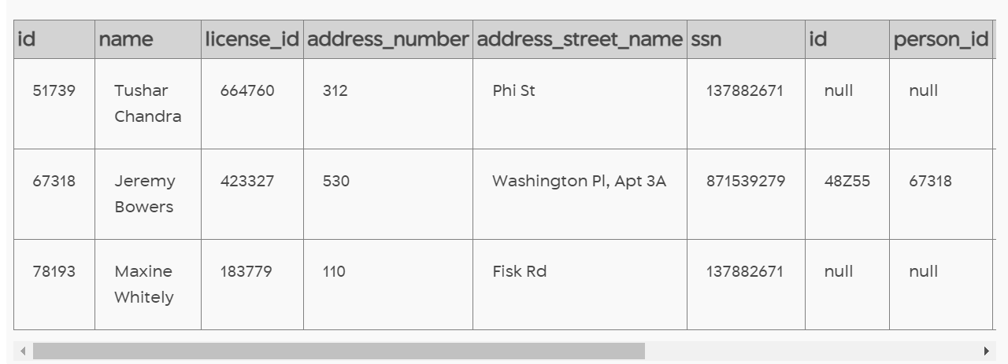

**STEP 10**

**SELECT p. * , ci.* FROM drivers_license as d1 INNER JOIN person as p on d1.id = p.license_id INNER JOIN get_fit_now_member as gf on p.id = gf.person_id INNER JOIN get_fit_now_check_in as ci on gf.id = ci.membership_id WHERE plate_number LIKE '%H42W%' AND membership_status = 'gold' LIMIT 10**

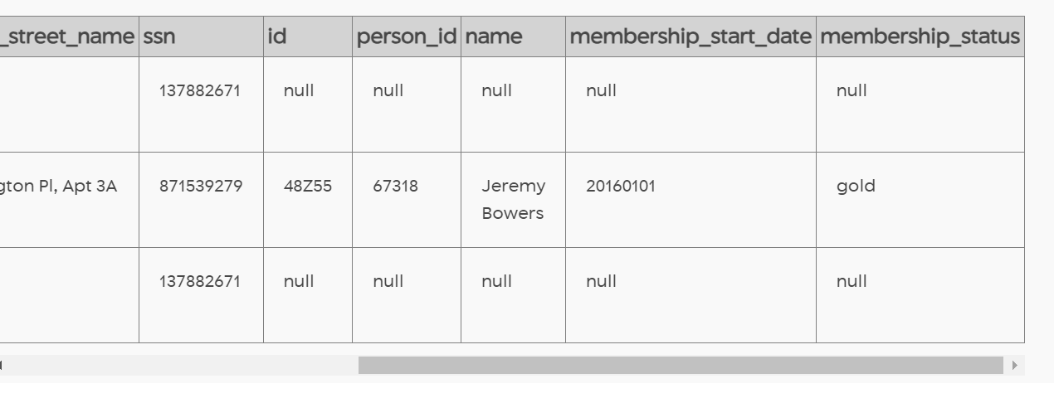

**--STEP 11**

**SELECT p. * , ci.* FROM drivers_license as d1 INNER JOIN person as p on d1.id = p.license_id INNER JOIN get_fit_now_member as gf on p.id = gf.person_id INNER JOIN get_fit_now_check_in as ci on gf.id = ci.membership_id WHERE plate_number LIKE '%H42W%' AND membership_status = 'gold' AND check_in_date = 20180109 LIMIT 10**

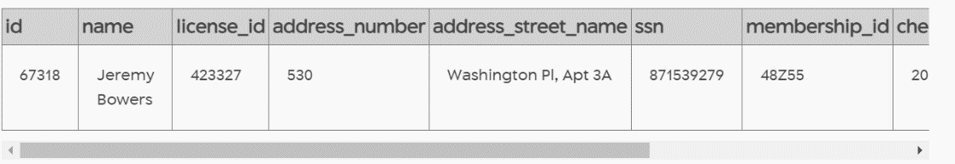

**STEP 12**

**INSERT INTO solution VALUES (1, 'Jeremy Bowers');**

**SELECT value FROM solution;**

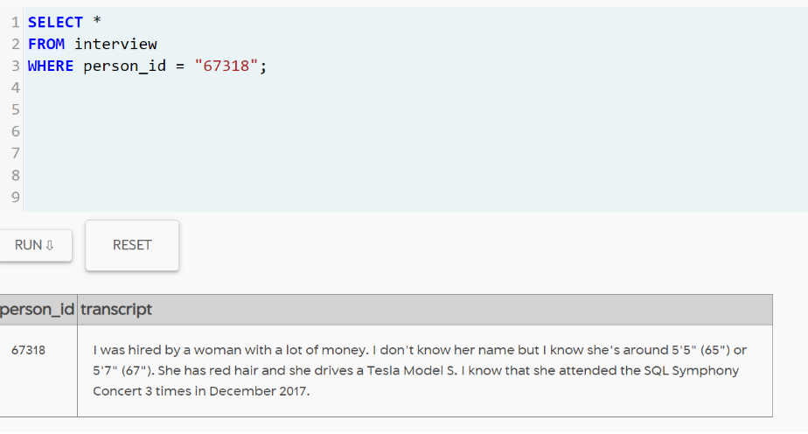

**STEP 13**

**SELECT \***

**FROM interview**

**WHERE person_id = "67318";**

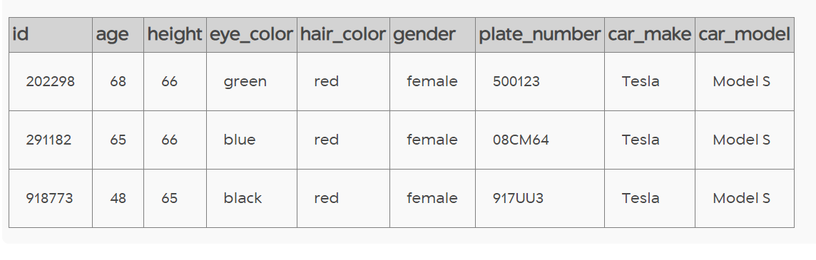

**STEP 14**

**SELECT \***

**FROM drivers_license**

**WHERE gender = "female"**

**AND hair_color = "red"**

**AND height BETWEEN 65 AND 67**

**AND car_make = "Tesla"**

**AND car_model = "Model S";**

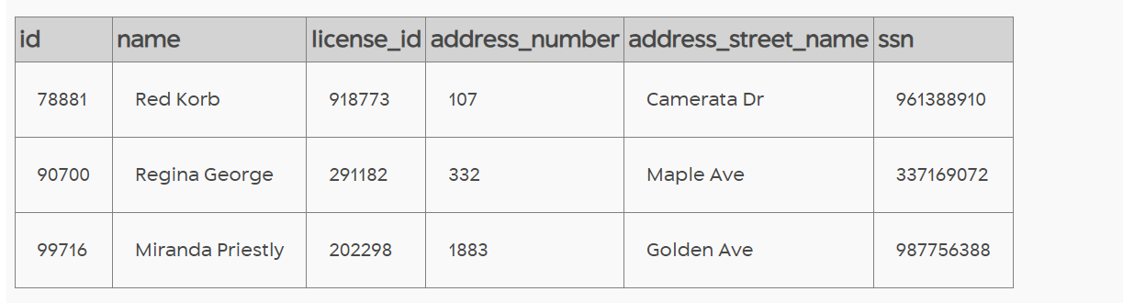

**STEP 15**

**SELECT \***

**FROM person**

**WHERE license_id IN ("202298", "291182", "918773");**

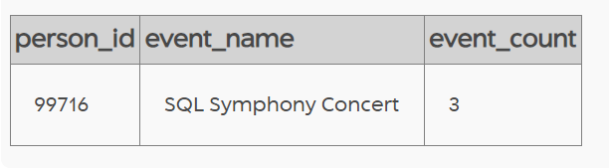

**STEP 16**

**SELECT**

**person_id,**

**event_name,**

**COUNT(*) AS event_count**

**FROM facebook_event_checkin**

**WHERE person_id IN ("78881", "90700", "99716")**

**GROUP BY person_id, event_name;**



**STEP 17**

**INSERT INTO solution VALUES (1, 'Miranda Priestly');**

**SELECT value FROM solution;**

